**HO CHI MINH CITY UNIVERSITY TECHNOLOGY AND EDUCATION**

🞠◊🞠◊🞠



**LECTURER**

**Le Van Vinh**

**Project 3**

**DBSCAN ALGORITHM**

**GROUP MEMBERS:**

**Phan Hoang Long-17110046**

**Truong Minh Quan-17110069**

**SEMESTER: 1 – YEAR: 2020-2021**

**HO CHI MINH CITY**

# EVALUATION AND SCORE

## **EVALUATION:**

## **SCORE:**

|  |  |
| --- | --- |
| **WORD** | **NUMBER** |
|  |  |

# PREFACE

This project helps us implement knowledge for the Machine Learning this semester. Although, we also have some problems while doing it, Mr.Vinh helps us to come over the challenges. We are grateful for his help and enthusiastic.

Thank you,

Mr.Vinh

Le Van Vinh

Contents

**EVALUATION AND SCORE 2**

**EVALUATION: 2**

**SCORE: 2**

**PREFACE 3**

**I. Clustering 5**

**1.1 What is Clustering? 5**

**1.2 Types of Clustering 5**

**1.3 Types of Clustering Algorithms 5**

**1.4 Some Typical Clustering Algorithms 6**

**II. DBSCAN Algorithm 7**

**1.1 What is DBSCAN Algorithm 7**

**1.2 Implementation 8**

**1.3 Demo 8**

1. **Clustering** 
   1. **What is Clustering?**

Clustering is the task of dividing the population or data points into a number of groups such that data points in the same groups are more similar to other data points in the same group than those in other groups. In simple words, the aim is to segregate groups with similar traits and assign them into clusters.

Let’s understand this with an example. Suppose, you are the head of a rental store and wish to understand preferences of your costumers to scale up your business. Is it possible for you to look at details of each costumer and devise a unique business strategy for each one of them? Definitely not. But, what you can do is to cluster all of your costumers into say 10 groups based on their purchasing habits and use a separate strategy for costumers in each of these 10 groups. And this is what we call clustering.

* 1. **Types of Clustering**

Clustering can be divided into two subgroups :

**+Hard Clustering:** In hard clustering, each data point either belongs to a cluster completely or not. For example, in the above example each customer is put into one group out of the 10 groups.

**+Soft Clustering**: In soft clustering, instead of putting each data point into a separate cluster, a probability or likelihood of that data point to be in those clusters is assigned. For example, from the above scenario each costumer is assigned a probability to be in either of 10 clusters of the retail store.

* 1. **Types of Clustering Algorithms**

**Connectivity models:** As the name suggests, these models are based on the notion that the data points closer in data space exhibit more similarity to each other than the data points lying farther away. These models can follow two approaches. In the first approach, they start with classifying all data points into separate clusters & then aggregating them as the distance decreases. In the second approach, all data points are classified as a single cluster and then partitioned as the distance increases. Also, the choice of distance function is subjective. These models are very easy to interpret but lacks scalability for handling big datasets. Examples of these models are hierarchical clustering algorithm and its variants.

**Centroid models:** These are iterative clustering algorithms in which the notion of similarity is derived by the closeness of a data point to the centroid of the clusters. K-Means clustering algorithm is a popular algorithm that falls into this category. In these models, the no. of clusters required at the end have to be mentioned beforehand, which makes it important to have prior knowledge of the dataset. These models run iteratively to find the local optima.

**Distribution models:** These clustering models are based on the notion of how probable is it that all data points in the cluster belong to the same distribution (For example: Normal, Gaussian). These models often suffer from overfitting. A popular example of these models is Expectation-maximization algorithm which uses multivariate normal distributions.

**Density Models:**These models search the data space for areas of varied density of data points in the data space. It isolates various different density regions and assign the data points within these regions in the same cluster. Popular examples of density models are DBSCAN and OPTICS.

* 1. **Some Typical Clustering Algorithms**

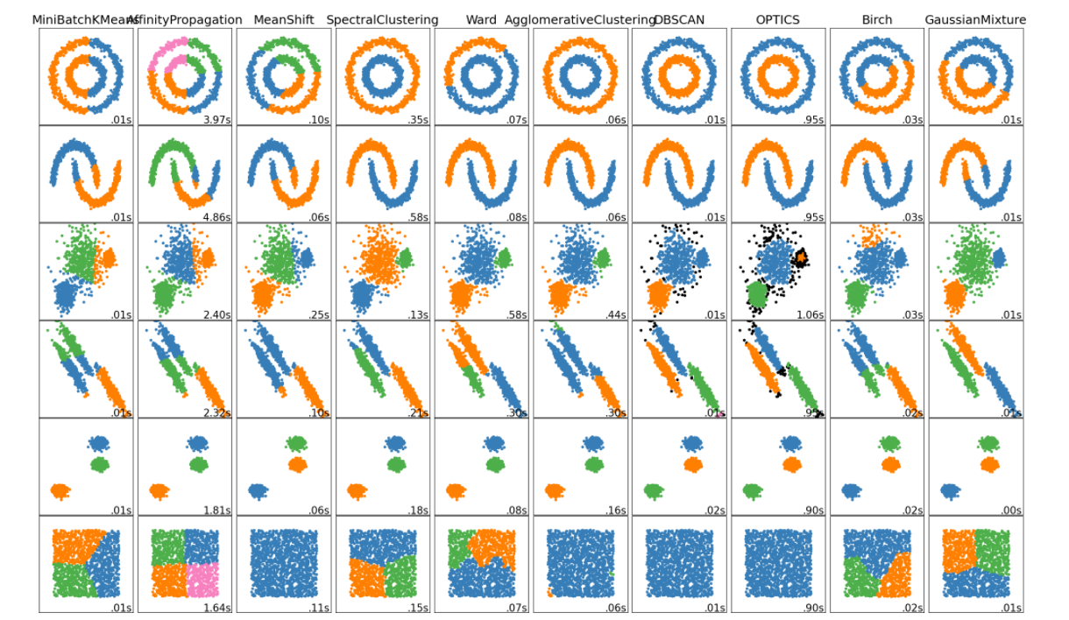

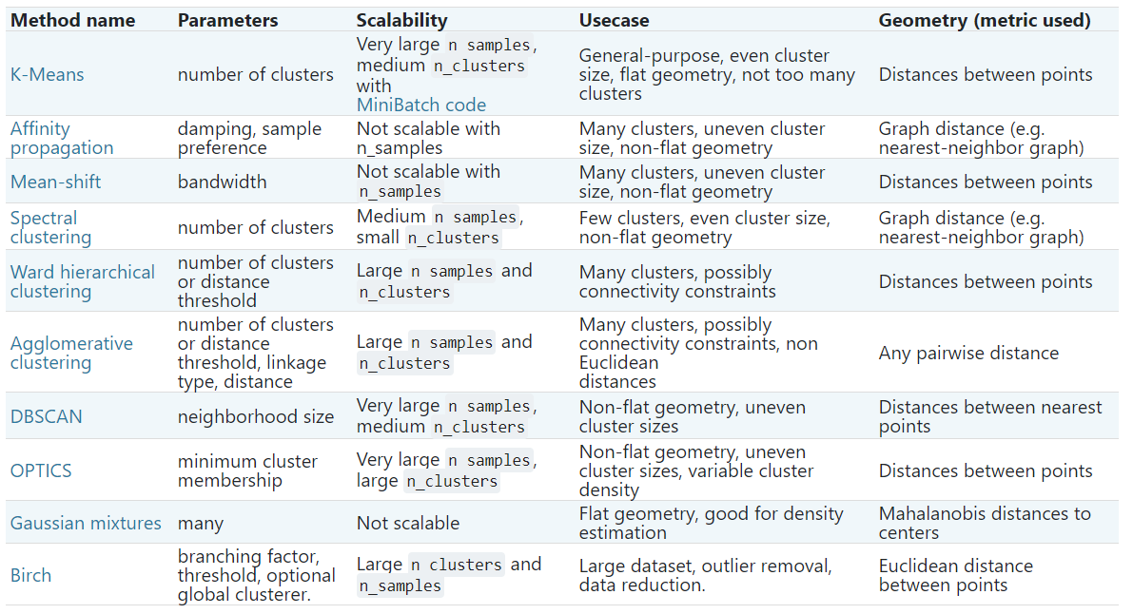

1. **DBSCAN Algorithm**
   1. **What is DBSCAN Algorithm**

The [DBSCAN](https://scikit-learn.org/stable/modules/generated/sklearn.cluster.DBSCAN.html#sklearn.cluster.DBSCAN) algorithm views clusters as areas of high density separated by areas of low density. Due to this rather generic view, clusters found by DBSCAN can be any shape, as opposed to k-means which assumes that clusters are convex shaped. The central component to the DBSCAN is the concept of *core samples*, which are samples that are in areas of high density. A cluster is therefore a set of core samples, each close to each other (measured by some distance measure) and a set of non-core samples that are close to a core sample (but are not themselves core samples). There are two parameters to the algorithm, min_samples and eps, which define formally what we mean when we say *dense*. Higher min_samples or lower eps indicate higher density necessary to form a cluster.

More formally, we define a core sample as being a sample in the dataset such that there exist min_samples other samples within a distance of eps, which are defined as *neighbors* of the core sample. This tells us that the core sample is in a dense area of the vector space. A cluster is a set of core samples that can be built by recursively taking a core sample, finding all of its neighbors that are core samples, finding all of *their* neighbors that are core samples, and so on. A cluster also has a set of non-core samples, which are samples that are neighbors of a core sample in the cluster but are not themselves core samples. Intuitively, these samples are on the fringes of a cluster.

Any core sample is part of a cluster, by definition. Any sample that is not a core sample, and is at least eps in distance from any core sample, is considered an outlier by the algorithm.

While the parameter min_samples primarily controls how tolerant the algorithm is towards noise (on noisy and large data sets it may be desirable to increase this parameter), the parameter eps is *crucial to choose appropriately* for the data set and distance function and usually cannot be left at the default value. It controls the local neighborhood of the points. When chosen too small, most data will not be clustered at all (and labeled as -1 for “noise”). When chosen too large, it causes close clusters to be merged into one cluster, and eventually the entire data set to be returned as a single cluster.

* 1. **Implementation**

The DBSCAN algorithm is deterministic, always generating the same clusters when given the same data in the same order. However, the results can differ when data is provided in a different order. First, even though the core samples will always be assigned to the same clusters, the labels of those clusters will depend on the order in which those samples are encountered in the data. Second and more importantly, the clusters to which non-core samples are assigned can differ depending on the data order. This would happen when a non-core sample has a distance lower than eps to two core samples in different clusters. By the triangular inequality, those two core samples must be more distant than eps from each other, or they would be in the same cluster. The non-core sample is assigned to whichever cluster is generated first in a pass through the data, and so the results will depend on the data ordering.

This implementation is by default not memory efficient because it constructs a full pairwise similarity matrix in the case where kd-trees or ball-trees cannot be used (e.g., with sparse matrices). This matrix will consume n^2 floats. A couple of mechanisms for getting around this are:

+Use [OPTICS](https://scikit-learn.org/stable/modules/clustering.html#optics) clustering in conjunction with the extract_dbscan method. OPTICS clustering also calculates the full pairwise matrix, but only keeps one row in memory at a time (memory complexity n).

+A sparse radius neighborhood graph (where missing entries are presumed to be out of eps) can be precomputed in a memory-efficient way and dbscan can be run over this with metric='precomputed'.

+The dataset can be compressed, either by removing exact duplicates if these occur in your data, or by using BIRCH. Then you only have a relatively small number of representatives for a large number of points. You can then provide a sample_weight when fitting DBSCAN.

* 1. **Demo**

We take an example from ScikitLearn.org

<https://github.com/LongPhan2307/Proj3_DBScan/blob/main/DBScan%20Algorithm%20Demo.ipynb>

Here the result:

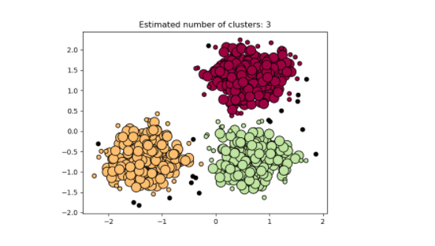

1. **Preferences**

<https://www.analyticsvidhya.com/blog/2016/11/an-introduction-to-clustering-and-different-methods-of-clustering/#:~:text=Clustering%20is%20the%20task%20of,and%20assign%20them%20into%20clusters>.

<https://scikit-learn.org/stable/modules/clustering.html#dbscan>